**SP TOOL**

**URL: https://serviceonline.gov.in/**

* **Requirement:-**

Creating a Report in respect of Search GP Level and Dashboard Report.

* **Configuration:-**

Following are the work to be done in SP TOOL before starting service configuration.

1. **Search GP level Income Certificate**
2. **Dashboard Report of Particular GP**

**Functionality 1**: To configure report of particular service which has search criteria as **Application Ref. No** or **Document No.** which is submitted in Application Form.

* **Example**:

We are now going to configure how to report for **Application for Issuance of Income Certificate - GP** Servicewhich will demonstrate you how to search with **Application Ref. No** or **Document No.**

* + **Step 1:-**

Go to 🡪 **Definition**

Fill **Report Title** to **🡪 Search GP Level Income Certificate**

Fill **Report Short Title** to **🡪 Income Application**

Select **Report Type** to **🡪 Single Service**

Select **Service Department** to **🡪 Panchayat and Rural Department** and select the respective service you are doing for **🡪 Application for Issuance of Income Certificate – GP**

**Now Select 🡪 Yes** for🡪 **Is there any input criteria to filter the parameters of this report**

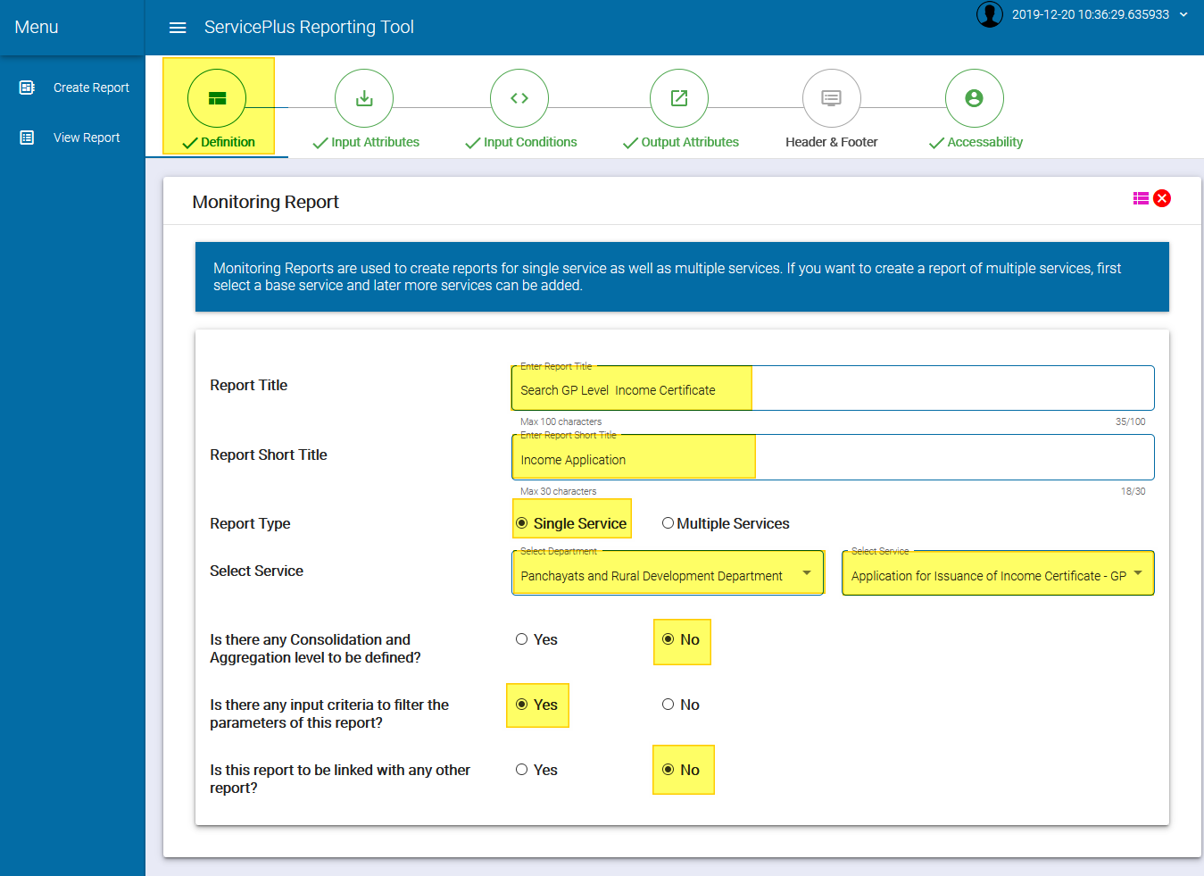

* + **Step 2:-**

Go to 🡪 **Input Attributes**

Drag & Drop attributes to 🡪**Selected Attributes 🡪 Document No. & Application Reference No.**

Now Define the Label Name for 🡪 Document No. to 🡪 **Document No.**

And Define the Label Name for 🡪 Application Reference No. to 🡪 **Income Certificate No.**

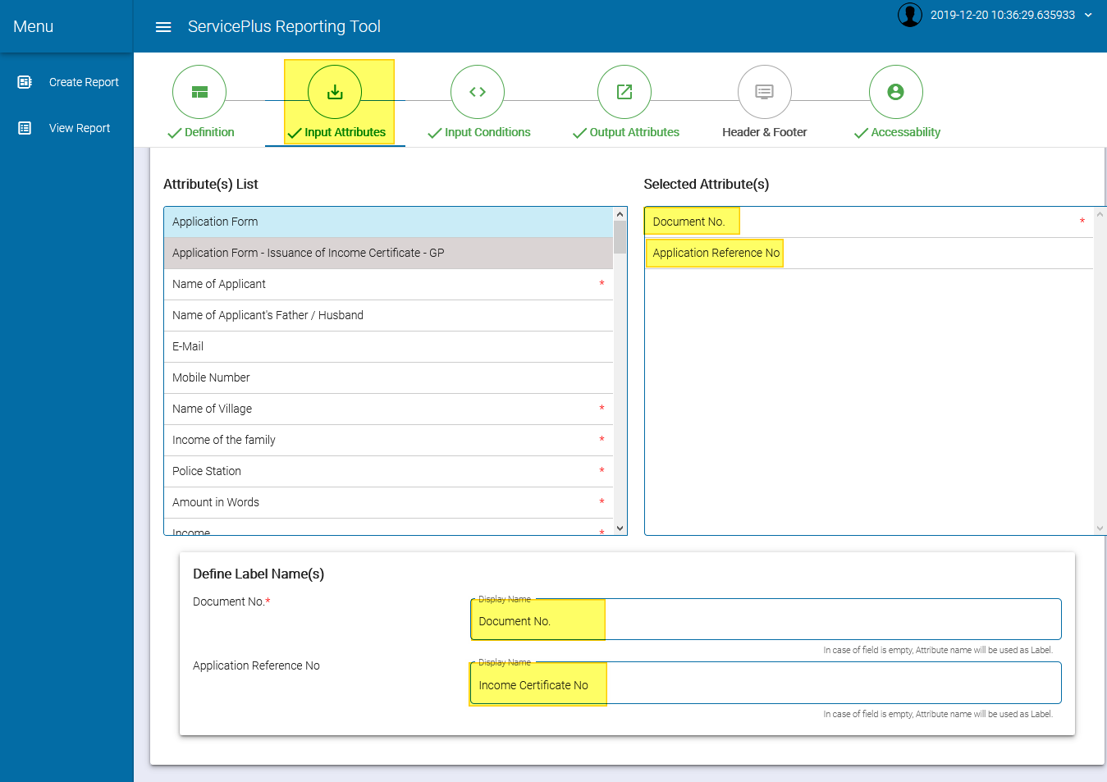

* + **Step 3:-**

Go to 🡪 **Input Conditions**

* + **Step 4:-**

Go to 🡪 **Output Attributes**

Drag & Drop Application Attributes to 🡪 **Considered Attributes 🡪 Consolidated Attributes 🡪 Output Attributes**

Now define the each Label Name for the **output attributes.**

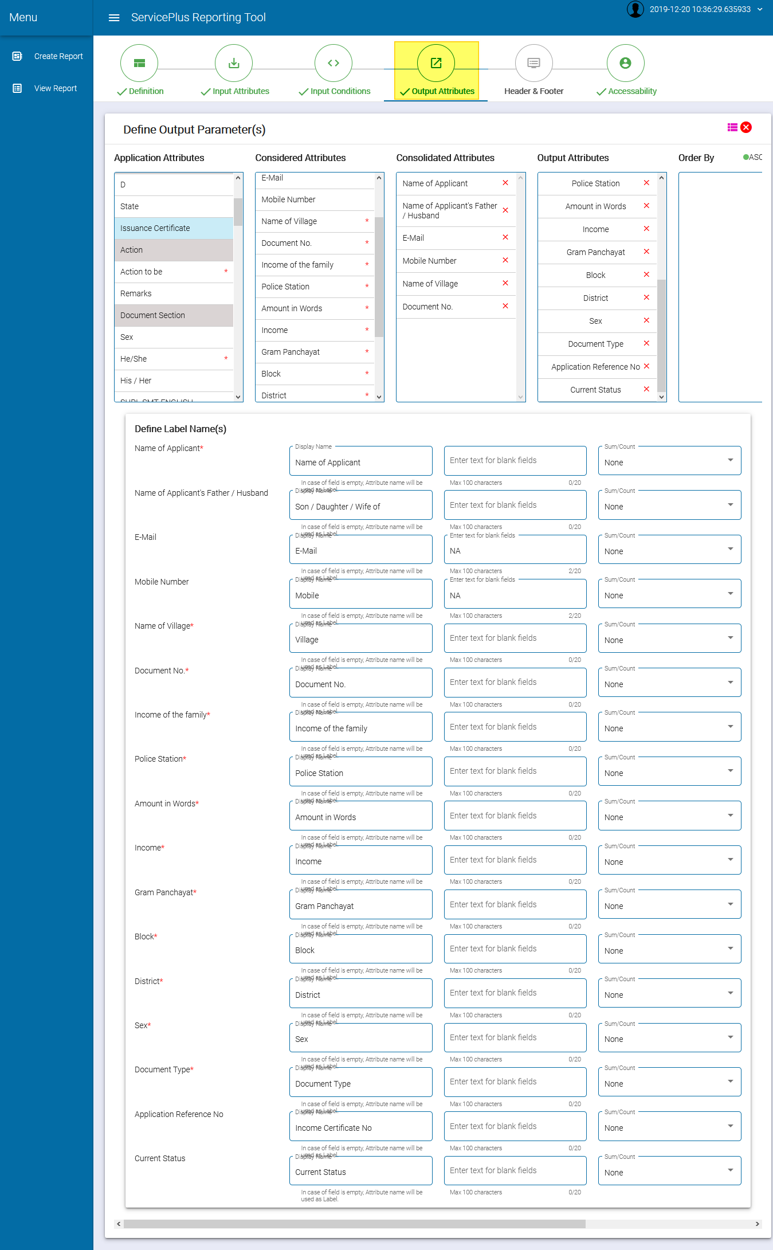

* + **Step 5:-**

Go to 🡪 **Accessibility**

Click on **Add Row**

**Selected Role Level** to **🡪 Department Admin**

**Select Area** to **🡪 Rural Local Body**

And **Select Local Body Type** to **🡪 Intermediate Panchayat**

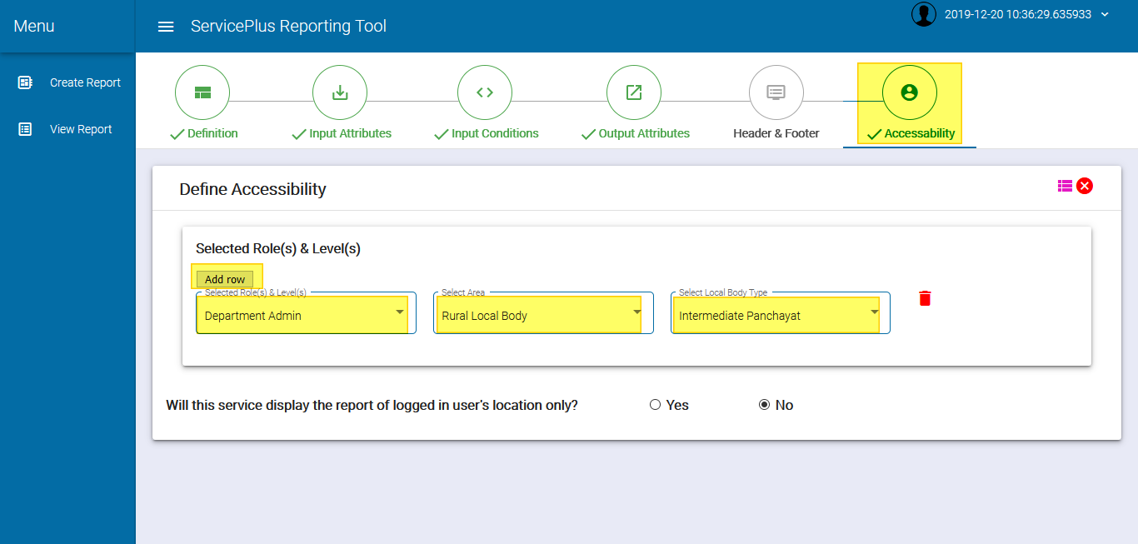

**Functionality 2:-** To configure report of getting all the dashboard data of activated services which are Delivered, Rejected, In Progress and Received, **Dashboard Report of Particular GP**

* **Example**:

We are now going to configure how to report for **Application for Issuance of Completion Certificate - GP** Servicewhich will demonstrate you how to get report of activated services.

* + **Step 1:**

Go to 🡪 **Definition**

Fill **Report Title** to🡪 **Dashboard Report of Particular GP**

Fill **Report Short Title** to🡪 **Dashboard of Particular GP**

Select **Report Type** to🡪 **Multiple Services**

Select **Department** to🡪 **Panchayat and Rural Department** and select the respective service you are doing for 🡪 **Application for Issuance of Completion Certificate – GP**

**Now Select** 🡪 **Yes** for🡪 **Is there any input criteria to filter the parameters of this report**

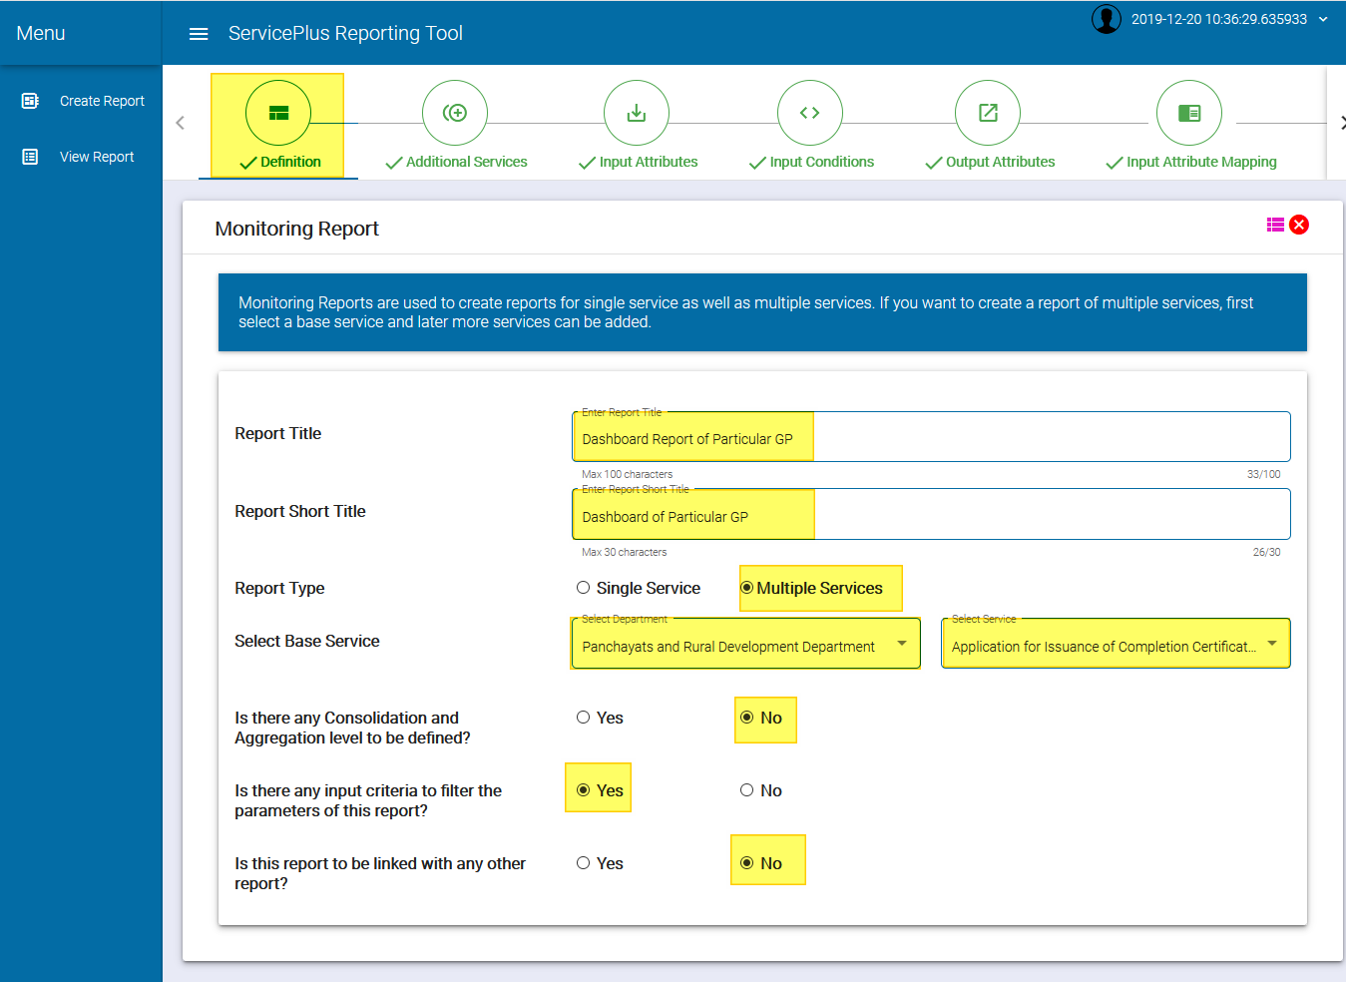

* + **Step 2:**

Go to 🡪 **Additional Services**

Drag & Drop from Department List to 🡪**Selected Department** 🡪 **Panchayat and Rural Development Department**

Now Drag & Drop from Service List to 🡪 **Selected Services.**

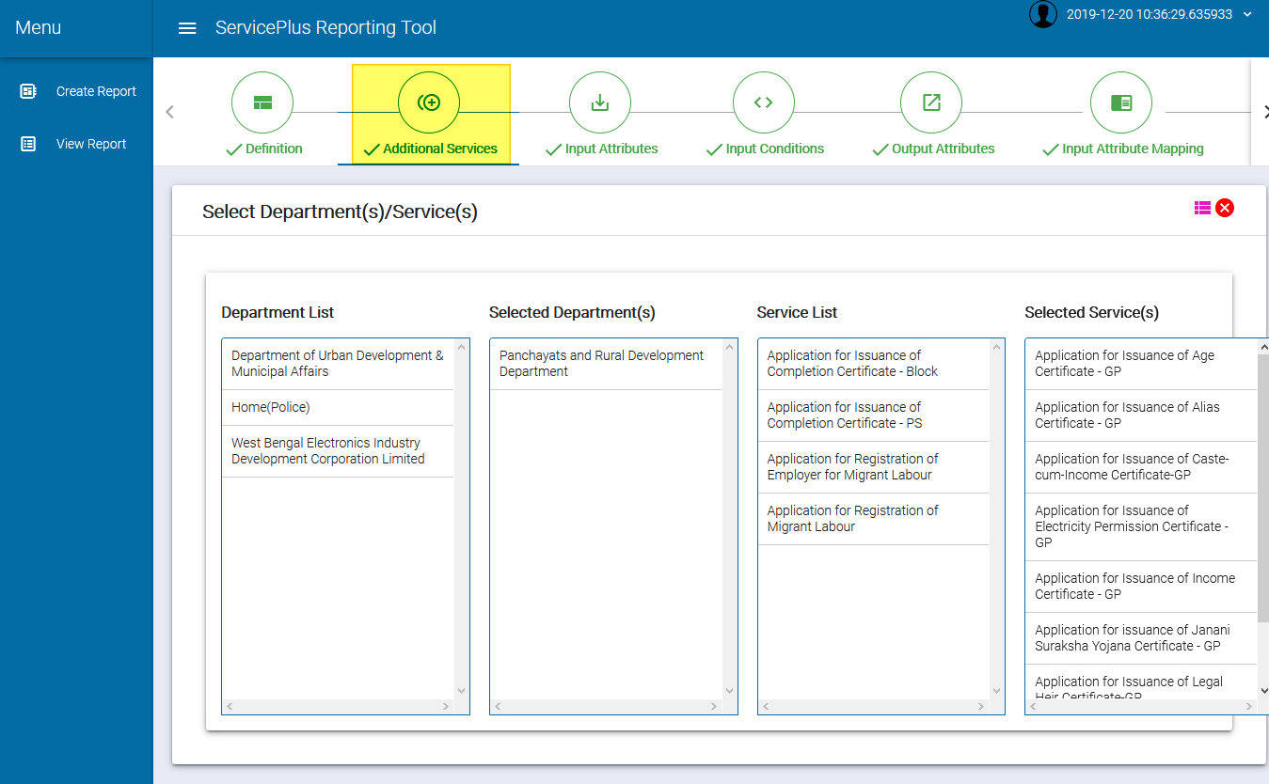

* + **Step 3:-**

Go to 🡪 **Input Attributes**

Drag & Drop attributes to 🡪**Selected Attributes 🡪 Submission Location.**

Now Define the Label Name for 🡪 Submission Location. to 🡪 **Gram Panchayat.**

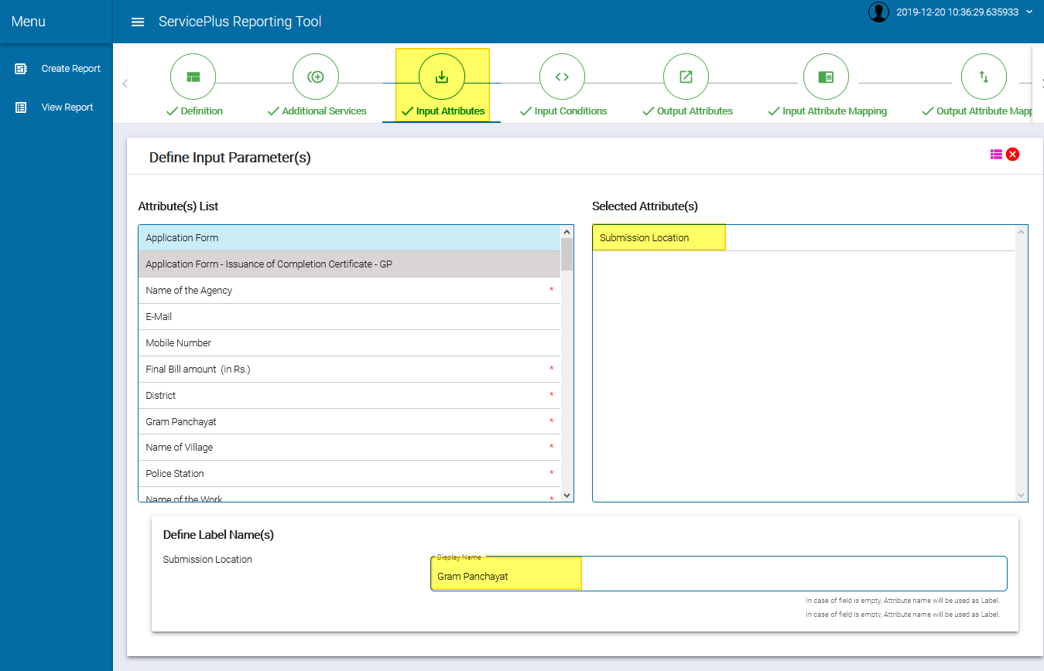

* + **Step 4:-**

Go to 🡪 **Input Conditions**

* + **Step 5:-**

Go to 🡪 **Output Attributes**

Drag & Drop Application Attributes to 🡪 **Considered Attributes 🡪 Consolidated Attributes 🡪 Output Attributes 🡪 Order By 🡪 Group & Aggregation**

Now define the each Label Name for the **output attributes.**

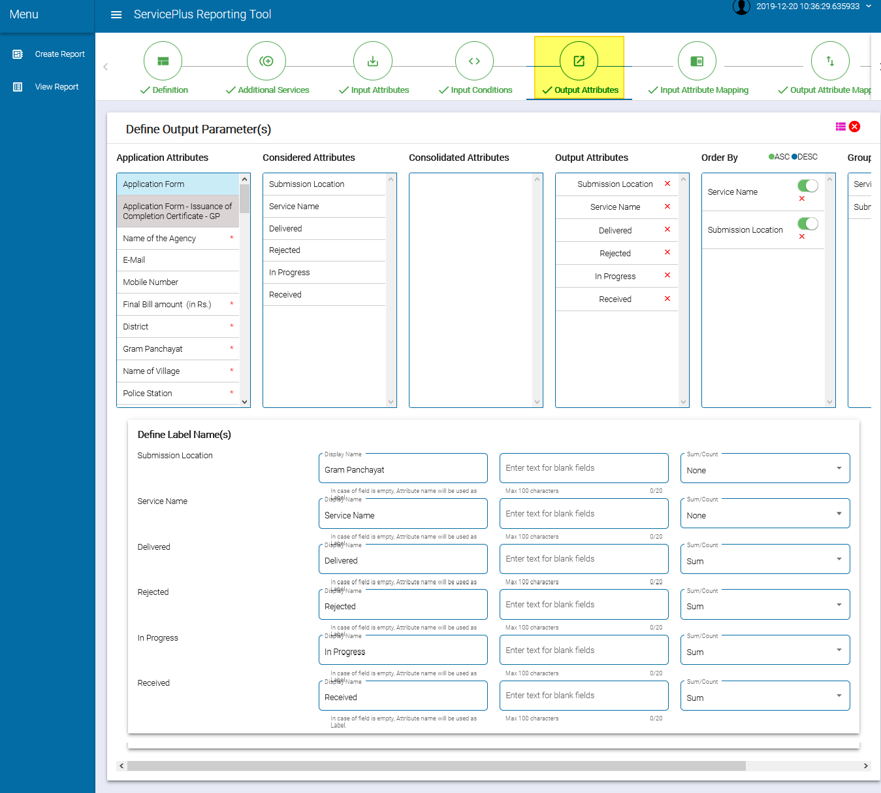

* + **Step 6:-**

Go to 🡪 **Input Attribute Mapping**

Select the **Submission Location**

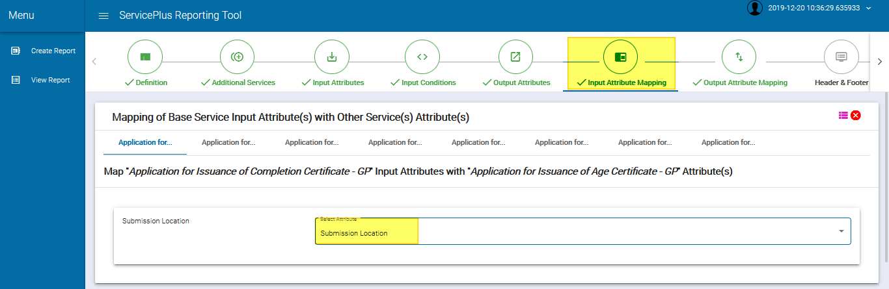

* + **Step 7:-**

Go to 🡪 **Output Attribute Mapping**

Select the **Delivered 🡪 Rejected 🡪 In Progress 🡪 Received**

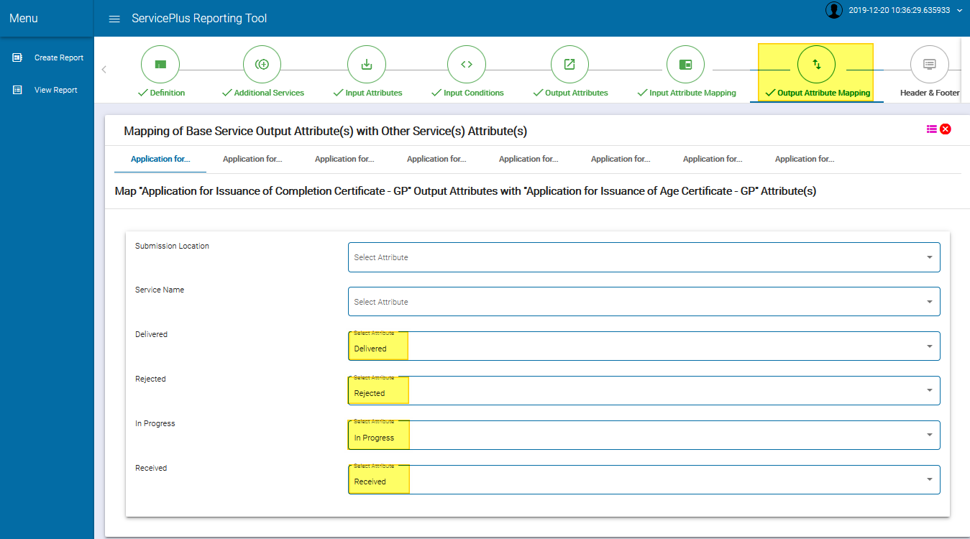

* + **Step 8:-**

Go to 🡪 **Accessibility**

Click on **Add Row**

**Selected Role Level** to **🡪 State Service Definer**

**Select Area** to **🡪 Line Department**

And **Select Designation** to **🡪 Panchayat and Rural Development**

And **Select Designation Level** to **🡪 STATE**

And **Select Office Level** to **🡪 Panchayat and Rural Development**

